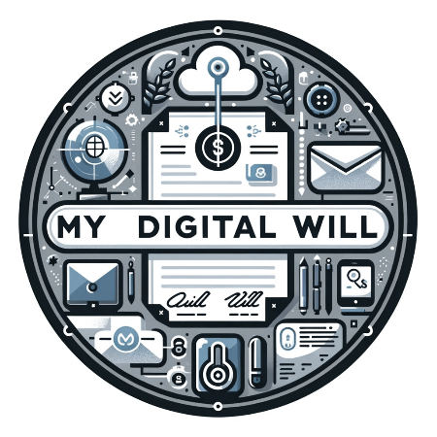

Project documentation 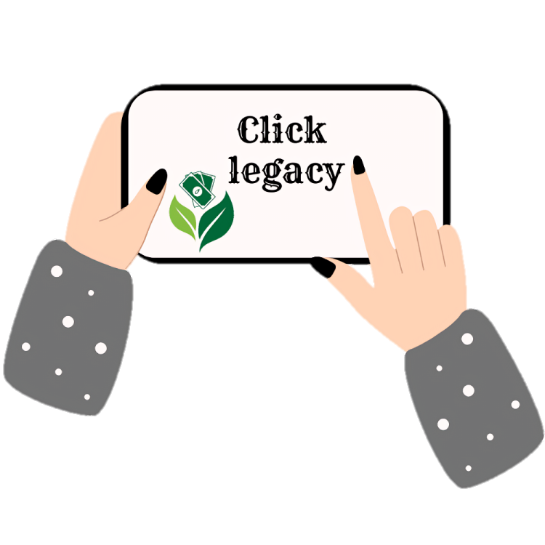

Table of Contents

Resume 2

Team 2

Idea 3

Used programs 3

How difficult it was? 3

# Resume

In our 10th-grade project, Click Legacy, our team developed a revolutionary app focused on digital wills. We created a user-friendly platform. Click Legacy empowers users to manage the distribution of their possessions, including money, property, and shares, with the flexibility to modify decisions at any given time. Our goal is to provide everyone with a mobile device easy access to their digital will, making the process efficient and customizable.

# Team

* Kristina Zheleva (Scrum trainer)  
  [KMZheleva21@codingburgas.bg](mailto:KMZheleva21@codingburgas.bg)
* Martin Belchev (Backend developer)  
  [MDBelchev21@codingburgas.bg](mailto:MDBelchev21@codingburgas.bg)
* Simeon Syarov (Backend developer)  
  [SMSyarov21@codingburgas.bg](mailto:SMSyarov21@codingburgas.bg)
* Stiliyan Ivanov (Backend developer)  
  [STIvanov21@codingburgas.bg](mailto:STIvanov21@codingburgas.bg)
* Nikola Kachikov (Designer)  
  [NSKachikov21@codingburgas.bg](mailto:NSKachikov21@codingburgas.bg)

# Idea

The goal of our application is for anyone with a mobile device to have access to their digital will. Through the app, users will be able to change the distribution of their holdings, such as money, property, shares, etc., at any time

# Used programs

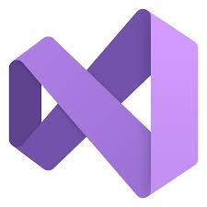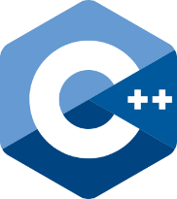

# How difficult it was?

|  |
| --- |
| Difficulties: |
| 1/10 – not difficult \ 10/10 – very difficult |

|  |  |
| --- | --- |
| Communication | 7/10 |
| Code | 4/10 |
| Teamwork | 9/10 |
| Role distribution | 7/10 |